# WINSCP and PUTTY setup (written by: Timothy Lim, version 22/03/2024)

#This is to setup WINSCP (for file management) and PUTTY (for requesting MASSIVE sessions and run QIIME/SourceTracker/other modules). This is assuming that you have gotten access to MASSIVE account.

## WINSCP

#First, look at your email with keyword *M3 - user account provisioned - xxyy (project number)*. It should have your *SSH to login node* details available. Open WINSCP, and put in the following details and click *login*:

* File protocol: SFTP
* Host name: m3.massive.org.au
* Port number: 22
* User name: *your assigned username*
* Password: *your Monash account password*

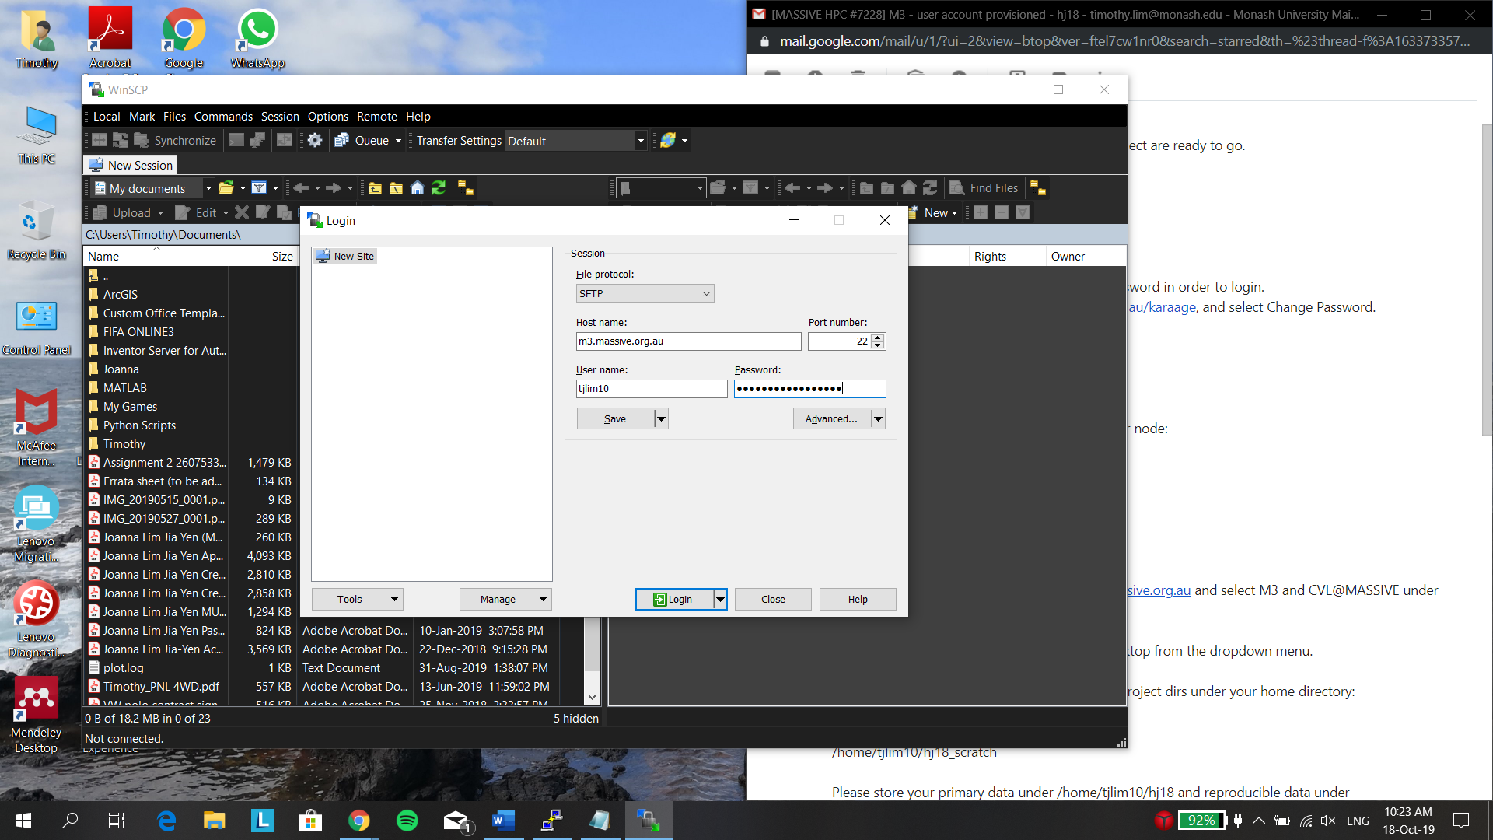

## PUTTY

# Open PUTTY, and fill in the following information based on the email MASSIVE sent to you:

Host name: *xxxxxxx@m3.massive.org.au (look under “SSH to Login node”)*

Port: 22

Connection type: SSH

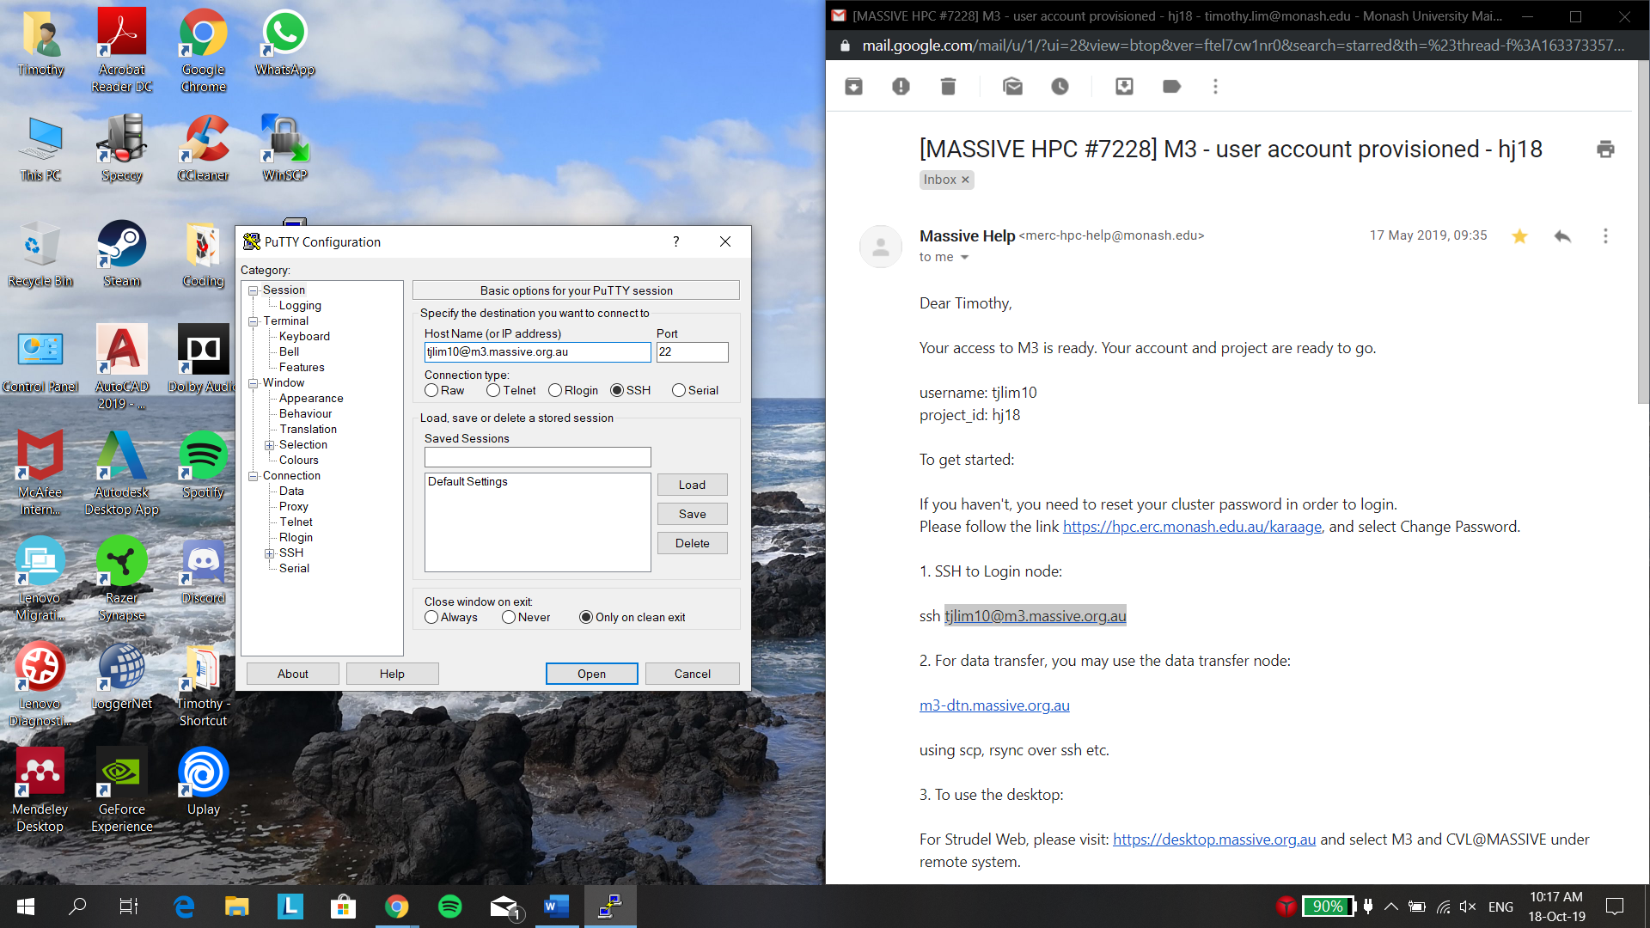

#Under Category: Go to Connection 🡪 SSH 🡪 X11, and enable X11 forwarding

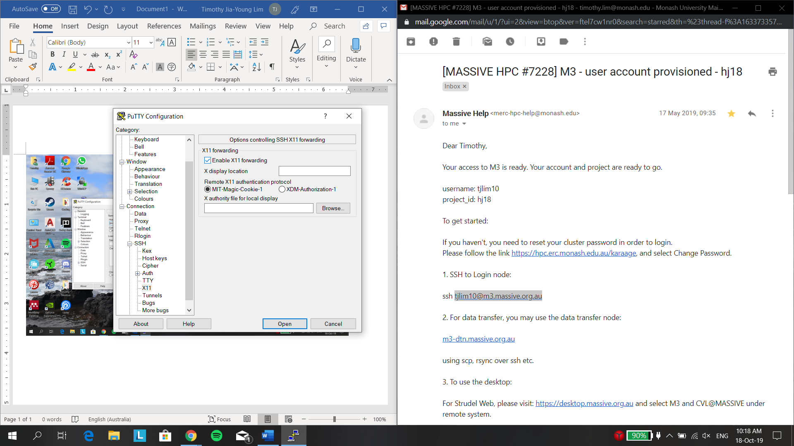

#Once this is done, login, key in password (password will not be shown), and click on enter